Lights Out! An Incident Response Game

Instructions
Goal: To effectively manage a public health emergency by collaborating with your team to make strategic decisions, allocate resources, and mitigate the impact of the crisis.
Time Frame: approximately 90 minutes
Objectives:
- Build Confidence in Emergency Response Concepts: Create a low-stakes environment to explore different strategies for disaster response.
- Understand Key ICS Roles and Responsibilities: Introduce Incident Command System concepts and help players learn what each Command Staff role (e.g., Incident Commander, Operations Section Chief, Logistics, Planning, Finance/Admin) does during an incident.
- Promote Team-Based Decision Making: Emphasize collaboration between roles to solve challenges through communication and coordination.
- Encourage Resource Management and Prioritization: Demonstrate allocation of limited resources (people, equipment, time, Etc.) to prioritize and address the changing needs throughout incident response.
- Have some fun: Enjoy the experience of playing the game and use that energy to drive further discussion and planning.

Setup
- Distribute Command, Operations, Logistics, Planning, and Finance roles to all players. If there are less than 5 players, some players will have multiple roles.
- Place the Metrics Tracking Sheet (sheet of paper to keep track of metrics during game) and Deck, Discard, Money Spent, and AAR Pile sheet where each player can read it.
- Place a token on 1 for Situation Progression and place one token on 3 for each Metric.
- Each role starts with 10 resource tokens to be spent on resolving activity and problem cards during the game. Players must use these resources to respond to the emergency scenario.
  - Each role has a Superpower with a “Once Per Game” action that it can use at any time, even during another player’s turn.
  - Each resource token is worth 5. For example: if a card states, “Operations spends 10 resources”, you will discard 2 tokens.
  - Place spent resources in the “Spent Resources” pile
- Shuffle the deck of Activity, Event, and Advantage cards.

How to play
- Pick a player to read the emergency scenario, which can be found on the metric tracking sheet. Command takes the first turn.
- The Active Player draws three cards from the deck. If the deck runs out of cards, shuffle the discard pile, and it becomes the deck. Resolve the cards in the following order. Figure 1 shows how to resolve each set of drawn cards. 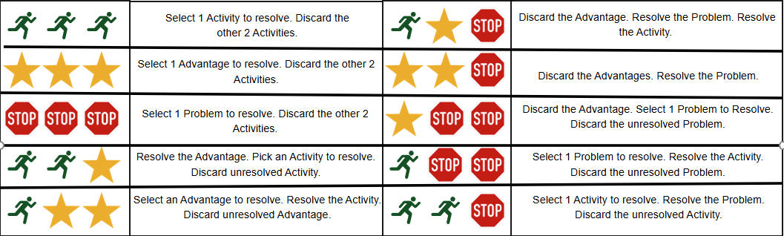
  - Resolve Problem:
    - If one or more Problem Cards are drawn, discard all Advantage Cards.
    - Resolve a Problem Card. If more than one Problem Card is drawn, choose one to resolve.
    - Select one option on the Problem card. Adjust metrics and spend resources as indicated.
  - Resolve Advantage:
    - If one or more Advantage Cards are drawn (and no Problem Cards), choose one to resolve.
  - Resolve Activity:
    - If more than one Activity was drawn, pick one to resolve. Players discuss and agree on which option to select.
    - If no consensus, the active player makes the final choice.
  - Put resolved cards in the After-Action Review Space.
  - Put any unresolved cards in the Discard Pile.
- The player to left of the Active Player becomes the next Active Player. Repeat Steps 3 and 4.
- If there are not enough cards in the deck to draw, shuffle the discard pile, place it in the Deck space, and the Active Player continues their turn.

Metrics to track
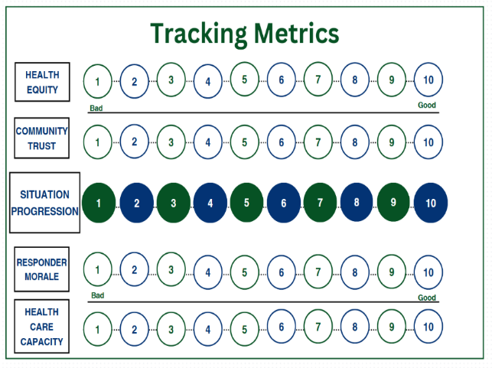
- Situation Progression: the overall progression of the game, the higher this gets to level 10, the closer the response is to being completed.
- Health Care Capacity: The ability of the health care systems to treat and care for patients.
- Health Equity: The amount of Health Equity throughout the community during the event/response.
- Community Trust: The amount of trust that the community has in its leaders while responding to the event/response.
- Responder Morale: The ability of responders to stay mentally and physically healthy while responding to the event.

Response superpower (once per game action)
- Each role has an action that can be used at any time. This can occur during a different players turn.
- Detailed explanation:
  - Command: At any time, Command may increase one Metric (i.e. Health Care Capacity, Health Equity, Responder Morale or Community Trust) by 1
  - Operations: If a Problem card was not drawn, the Active Player can resolve 2 Activity cards this turn. An Advantage card may still be resolved.
  - Planning: Look at the top 2 cards of the deck. For each card, choose if it goes on the top or bottom of the deck. Planning may choose the order if both are put on the top or bottom.
  - Logistics: Select any card (i.e. Advantage, Activity, or Problem) from the discard pile. Shuffle it into the deck.
  - Finance: Distribute a total of 30 resources to the other players (i.e. Command, Operations, Planning or Logistics). Finance may not receive any of these resources.

Game end conditions

Players win when:
- The Situation Progression reaches 10 on the track.
  - Final scoring: Add the Level of each metric. (i.e. if each Metric is at 10, the final score is 40 points).
- Select 3-5 questions from Hotwash to discuss.

Players lose when:
- Any metric reaches 0 on the track. When a metric reaches 0 on the track, it means you have reached a point in the metric where it makes it impossible to progress in the situation.
  - For example, if you reach 0 for Health Care Capacity, it means your healthcare system is overrun and can no longer take or treat patients.
- Select 3-5 questions from Hotwash to discuss.

After game hotwash questions:
- How did resource scarcity affect your discussions and/or decision-making?
- When did the game incentivize actions that you would not have prioritized in an exercise or real-world incident?
- What activities or situations from the game could be incorporated into your response plans?
- What did you learn about the responsibilities of the different ICS positions in the game?
  - What is your usual ICS role during an incident?
- The game uses Health Equity, Health Care Capacity, Responder Morale, and Community Trust as metrics to evaluate and track a successful response.
  - Would you use these metrics to evaluate an incident response?
  - What metrics do you use to evaluate incident responses at your organization?

Glossary

Emergency Scenario: Card sets up scenario, states facts, and gives relevant jurisdictional information for the game.

Metrics Tracking Sheet: Sheet used to track where the team is in the situation based on the Metrics (Health Care Capacity, Health Equity, Community Trust, and Responder Morale) and Situation Progression. The tracks are modified as directed when resolving cards.
Problem Cards: Problem cards must be resolved unless an Advantage is resolved. Problem cards have an overall negative effect on the scenario. Players have 2 options that they may use to increase a Metric. If two Problem Cards are drawn, the Active Player chooses one to resolve.

Activity Cards: Cards in play which are generally positive and give the player(s) and activity to progress/help the situation.

Advantage Cards: Advantage cards have a positive effect on the game. If 2 Advantage cards are drawn, the active player chooses one to resolve. If an Advantage and a Problem card are drawn, and the Problem card is not resolved.

