Minnesota Tobacco Substance Reporting Form
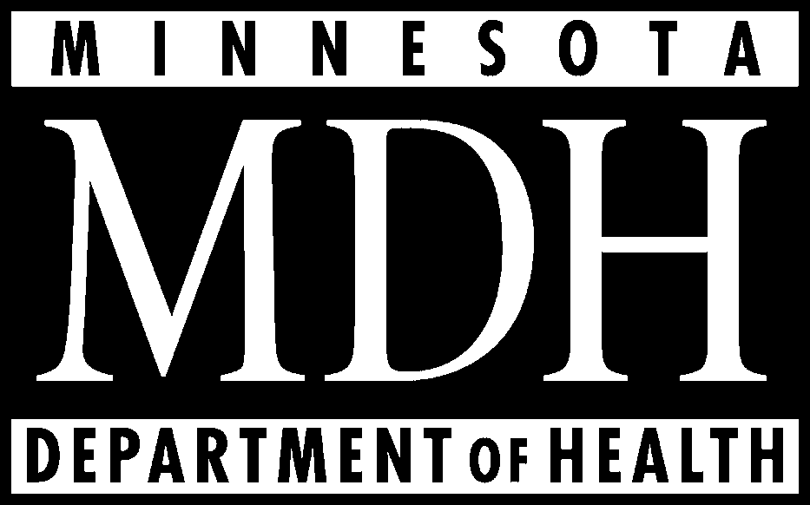
Part 2: Smokeless Tobacco

 |  | Unburned State
Brand, Sub Brand or  Generic Brand Name | Substance | g/g of whole tobacco | Detection limit of method
1. Ammonia or any
compound of ammonia
 | 2. Arsenic
 | 3. Cadmium
 | 4. Formaldehyde
 | 5. Lead

1. Ammonia or any
compound of ammonia
2. Arsenic
3. Cadmium
4. Formaldehyde
5. Lead

1. Ammonia or any
compound of ammonia
2. Arsenic
3. Cadmium
4. Formaldehyde
5. Lead

The Department of Health requests voluntary submission of the protocol used for testing.

Rev. February 2002

