Minnesota Tobacco Substance Reporting Form
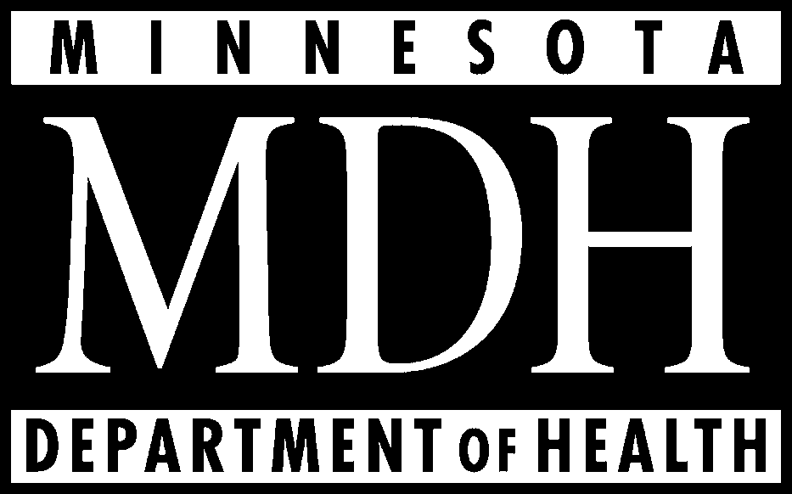
Part 4: Pipe or Roll Your Own

 |  | Unburned State |  | Burned State
 |  |  |  | Mainstream |  | Sidestream
Brand, Sub Brand or Generic Brand Name | Substance | g/g of whole tobacco | Detection limit of method | g of tobacco burned | Detection limit of method | g of tobacco burned | Detection limit of method
 Pipe   Loose Roll Your Own | 1. Ammonia or any  compound of ammonia
 Pipe   Loose Roll Your Own | 2. Arsenic
 Pipe   Loose Roll Your Own | 3. Cadmium
 Pipe   Loose Roll Your Own | 4. Formaldehyde
 Pipe   Loose Roll Your Own | 5. Lead

 Pipe   Loose Roll Your Own | 1. Ammonia or any  compound of ammonia
 Pipe   Loose Roll Your Own | 2. Arsenic
 Pipe   Loose Roll Your Own | 3. Cadmium
 Pipe   Loose Roll Your Own | 4. Formaldehyde
 Pipe   Loose Roll Your Own | 5. Lead

 Pipe   Loose Roll Your Own | 1. Ammonia or any  compound of ammonia
 Pipe   Loose Roll Your Own | 2. Arsenic
 Pipe   Loose Roll Your Own | 3. Cadmium
 Pipe   Loose Roll Your Own | 4. Formaldehyde
 Pipe   Loose Roll Your Own | 5. Lead

The Department of Health requests voluntary submission of the protocol used for testing.

Rev. February 2002

