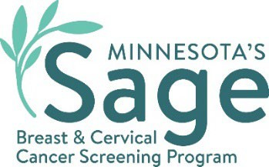

# SW Minnesota Breast Cancer Campaign Social Media Content

ENglish

## Precious Moments

Caption: Take care of your health and be there for those you love by having regular cancer screenings. Sage, Minnesota’s cancer screening program, can help you schedule your free mammogram and Pap test and pay for your services if you are uninsured or underinsured. Call Sage at 1-888-643-2584 and mention promo code SW1. [mnsage.com.](https://www.health.state.mn.us/diseases/cancer/sage/index.html)

#SWSageScreening

## Four women smiling with arms around each other. Caption reads mammograms save lives! Schedule yours today.Saves Lives

Caption: Sage, Minnesota’s cancer screening program, can help you schedule your free mammogram and Pap test and pay for your services if you are uninsured or underinsured. Call Sage at 1-888-643-2584 and mention promo code SW1. [mnsage.com.](https://www.health.state.mn.us/diseases/cancer/sage/index.html)

#SWSageScreening

## Role Model

Caption: The Sage Program offers free mammograms and Pap tests for those who qualify. Call 1-888-643-2584 and mention promo code SW1 to find out if you’re eligible and get scheduled today! [mnsage.com.](https://www.health.state.mn.us/diseases/cancer/sage/index.html)

#SWSageScreening

## Woman with a laptop with a slightly concerned look on her face. Caption reads Need help paying for a mammogram? Sage is here for you!Pay Help

Caption: The Sage Program works with clinics to offer free mammograms and Pap tests for those who qualify. Call 1-888-643-2584 and mention promo code SW1 to find out if you’re eligible and get scheduled today! [mnsage.com.](https://www.health.state.mn.us/diseases/cancer/sage/index.html)

#SWSageScreening

## images of women smiling and enjoying healthy activities together. Caption reads take care of yourself so you can be there for your loved ones. Schedule your mammogram today.Take Care

Caption: Sage, Minnesota’s cancer screening program, wants to help you get a free mammogram and Pap test so you can stay healthy. Call 1-888-643-2584 and mention promo code SW1 to find out if you’re eligible and get scheduled today! [mnsage.com.](https://www.health.state.mn.us/diseases/cancer/sage/index.html)

#SWSageScreening

## Mary Survivor Quote

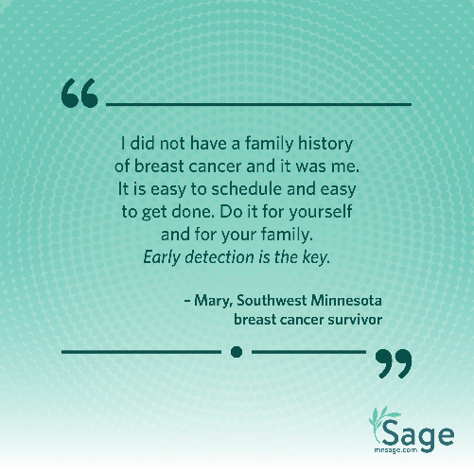Caption: We thank Mary for sharing her survivor story to raise awareness for breast cancer screening. Call 1-888-643-2584 and mention promo code SW1 to find out if you’re eligible for a free mammogram and get scheduled today! [mnsage.com](http://www.health.state.mn.us/diseases/cancer/sage/screening/index.html).  Read Mary’s full story here: [Sage Stories: Mary - MN Dept. of Health (state.mn.us)](https://www.health.state.mn.us/diseases/cancer/sage/sagestories/mary.html)

#SWSageScreening

## Amy Survivor Quote

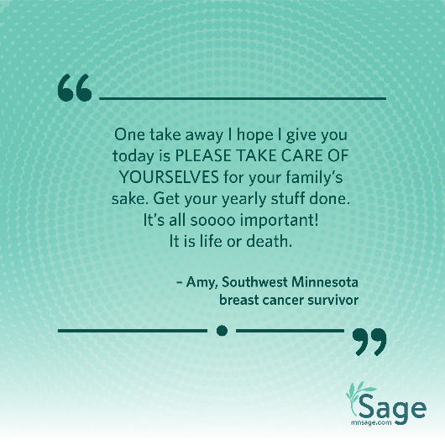Caption: We thank Amy for sharing her survivor story to raise awareness for breast cancer screening. Call 1-888-643-2584 and mention promo code SW1 to find out if you’re eligible for a free mammogram and get scheduled today! [mnsage.com](http://www.health.state.mn.us/diseases/cancer/sage/screening/index.html).  Read Amy’s full story here: [Sage Stories: Amy - MN Dept. of Health (state.mn.us)](https://www.health.state.mn.us/diseases/cancer/sage/sagestories/amy.html)

#SWSageScreening

## Halloween

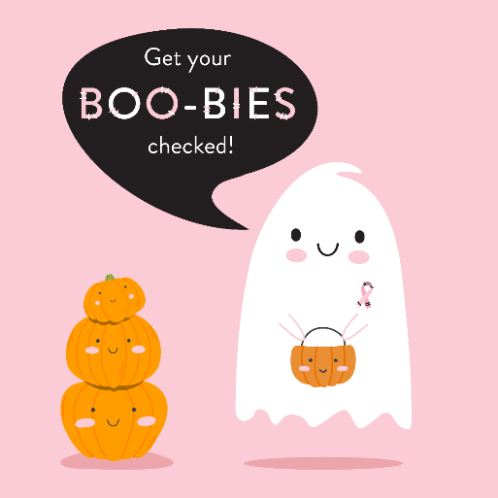Caption: Breast Cancer Awareness Month is wrapping up, but don’t forget to get your boo-bies checked! Call Sage at 1-888-643-2584 and mention code SW1 to schedule a free mammogram. Learn more at [mnsage.com.](https://www.health.state.mn.us/diseases/cancer/sage/index.html)

#BreastCancerAwarenessMonth #MNSage #SWSageScreening

## Alternate captions:

Early detection saves lives! If you’re a Minnesotan aged 40-64, take advantage of FREE Sage cancer screenings. Let’s fight breast and cervical cancer together! #BreastCancerAwarenessMonth2024 #MNSage #SWSageScreening

It’s time to prioritize your health! The Minnesota Sage Program offers FREE screenings for breast and cervical cancer. Don’t wait— call 1-888-643-2584 to find out if you qualify and schedule your appointment today. #SWSageScreening

Screening = Prevention! Sage provides mammograms and Pap tests to catch cancer early. Spread the word and encourage your loved ones to get screened. Together, we can make a difference! #BreastCancerAwarenessMonth #MNSage #SWSageScreening

If you’re eligible, take advantage of the Sage Program - Minnesota’s Breast & Cervical Cancer Screening Program. Early detection matters! #BreastCancerAwarenessMonth #SWSageScreening

Screening saves lives, and Sage is here for you! Whether it’s a mammogram or a Pap test, prioritize your health. Share this info with someone who needs it! Visit mnsage.com to learn more. #MNSage #SWSageScreening

Minnesota Department of Health  
Sage Program  
625 Robert St. N   
PO Box 64976  
St. Paul, MN 55155-2538  
888-643-2584  
health.sage@state.mn.us  
[www.health.state.mn.us](http://www.health.state.mn.us/)

08/07/2024

To obtain this information in a different format, call: 1-888-643-2584.