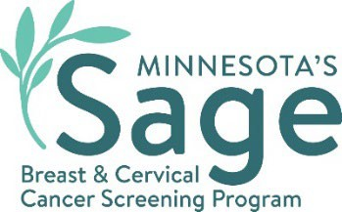

# SW Minnesota Breast Cancer Campaign Social Media Content

somali

## Precious Moments

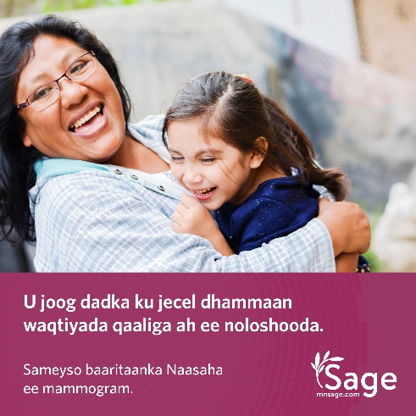 Caption: Caafimaadkaaga ka warqab oo u joog kuwa aad jeceshahay adiga oo si joogto ah u samaynaya baaritaanada kansarka. Barnaamijka baarista kansarka Minnesota ee Sage, ayaa kaa caawin kara in aad jadwal u sameysato baaristaada raajada naasaha (Mammogram) iyo Pap test (Ilma Galeenka Haweenka) ee bilaashka ah oo ay bixiso adeegyadaas haddii aadan caymis lahayn ama hadii aad caymis leedahaba. Ka wac Sage lambarka ah 1-888-643-2584. [mnsage.com](http://mnsage.com).

#SWSageScreening

## Saves Lives

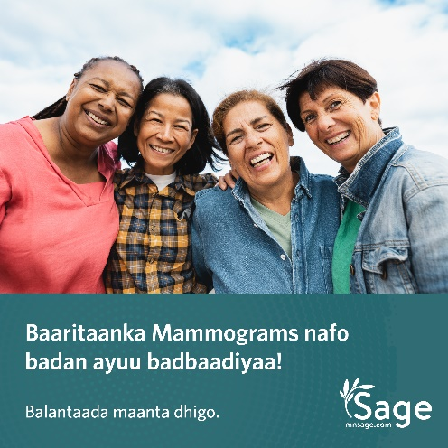Caption: Barnaamijka baarista kansarka Minnesota ee Sage, ayaa kaa caawin kara in aad jadwal u sameysato baaristaada raajada naasaha (Mammogram) iyo Pap test (Ilma Galeenka Haweenka) ee bilaashka ah oo ay bixiso adeegyadaas haddii aadan caymis lahayn ama hadii aad caymis leedahaba. Ka wac Sage lambarka ah 1-888-643-2584. [mnsage.com](http://mnsage.com).

#SWSageScreening

## Role Model

Caption: Barnaamijka Sage wuxuu bixiyaa baaritaanka naasaha ee mammograms iyo baaritaanka Pap test (Ilma Galeenka Haweenka) dadka u qalma.Wac 1-888-643-2584 si aad u ogaato haddii aad u qalanto oo isla maanta ballanso! [mnsage.com](http://mnsage.com).

#SWSageScreening

## Pay Help

Caption: Barnaamijka baarista kansarka Minnesota ee Sage, wuxuu la shaqeeyaa rugaha caafimaadka si ay u bixiyaan baaritaannada naasaha ee mammograms iyo Pap test (Ilma Galeenka Haweenka) oo bilaash ah dadka u qalma. Wac 1-888-643-2584 si aad u ogaato haddii aad u qalanto oo isla maanta ka ballanso! [mnsage.com](http://mnsage.com).

#SWSageScreening

## Take Care

Caption: Barnaamijka baarista kansarka Minnesota ee Sage, wuxuu rabaa in uu kaa caawiyo helitaanka baaritaanka naasaha ee mammogram iyo baaritaanka Pap test (Ilma Galeenka Haweenka) oo bilaash ah si aad caafimaad u qabto. Wac 1-888-643-2584 si aad u ogaato haddii aad u qalanto oo isla maanta ka ballanso! [mnsage.com](http://mnsage.com).

#SWSageScreening

Minnesota Department of Health  
Sage Program  
625 Robert St. N   
PO Box 64976  
St. Paul, MN 55155-2538  
888-643-2584  
health.sage@state.mn.us  
[www.health.state.mn.us](http://www.health.state.mn.us/)

08/07/2024

To obtain this information in a different format, call: 1-888-643-2584.